Non-Academic Careers

for STS Graduate Students:

A Workshop Report

by

Thomas Woodson

Rider W. Foley
Matthew Harsh

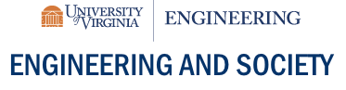


Issued: June, 2019
DOI.10.18130/V3-3AND-DQ72

Motivations and Aims
Science, Technology & Society (STS) graduate programs primarily train graduate students to work in academic jobs. Unfortunately, like many STEM fields, there are not enough academic jobs to match the supply of STS graduate students, nor does every STS graduate student want to become an academic. While this situation is not entirely recent, graduate students still do not receive adequate training or mentorship for careers outside of academia. Studies have shown that from 1998 to 2008, there was a 40% growth in the number of PhD in the world, and in high income countries like the USA, academia and industry have not been able to fully utilize all the PhDs (Cyranoski et al. 2011). Additionally, STS scholars, whose training spans sociology, anthropology, public policy, history and philosophy, are not aware of the value placed on their expertise in other sectors like industry, not for profit organizations, or government agencies. Thus, there is a critical need to introduce STS graduate students to careers outside of academia and expand their horizons to the available employment opportunities. In the absence of such training on the diversity of career options, there will continue to be far more STS graduates seeking academic positions than there are academic jobs. Not only is this leading to the disillusionment of STS graduate students and hurting the field, but it is also preventing STS from having a large impact outside of academia.
An ambitious goal for this work is to bring attention to shortcomings in STS curricula to better equip students for careers outside of academia. The more near-term goal was to host a one-day, pre-conference workshop at the 2017 Society for the Social Studies of Science (4S) meeting in Boston that provided STS graduate students the opportunity to interact and gain insights from STS scholars that successfully transitioned to non-Academic careers. The intended outcomes included: 1) introducing current STS graduate students to predecessors that are working outside of academia.; 2) helping STS students learn how the skill sets they acquire while in graduate school can make them competitive in non-academic job markets; and 3) giving voice to STS graduates that are working in non-academic careers and affording them an opportunity to give back to the field by contributing to the training and development of graduate students. An indirect goal was to initiate and help cultivate longer-term dialogue between non-academic STS professionals and STS graduate students. With these goals and outcomes in mind, the organizers aimed to create an environment of shared learning and produce a report that will reach broader audiences (beyond those in the room during the workshop) within the STS community. What follows is a brief review of the workshops structure and logistics before we share the key themes and takeaways from this work.

Workshop Structure and Logistics
While the original plan was to run one workshop to bring non-academic careers to the attention of STS graduate students, in the end, two workshops were held: one in the fall of 2017 and one in spring 2018. The first was a one-day workshop at MIT on August 29, 2017, a day before the 2017 4S conference (see Appendix A for agenda). The second was a half-day workshop at the National Academies of Science, Engineering and Medicines on March 24th during the ST Global conference (see Appendix B for agenda). The workshops were structured in similar ways with a panel of professionals that had matriculated from a STS (or closely related programs). The professionals worked in government, non-profit and private sectors and offered brief opening statements before the floor was opened to questions from the audience. The second part of the workshops focused on skills building and preparing non-academic job applications and those sessions were led by professional career counselors from MIT and Virginia Tech, respectively. The second portion offered an opportunity to gain advice from a professional on writing resumes, interviewing and negotiating. During the workshop, the project team divided roles between facilitating and notetaking. This report shares a synthesis of those notes, reflections and seeks to highlight key themes from the discussion.

Key Themes
The workshops made explicit a number of key themes that became central to the discussion and emphasize the need for those who train STS graduate students to consider how to translate academic competencies into other professional settings. In light of Mascarenhas (2018) critique of the racial and demographic diversity within STS faculties in the United States, this report calls attention to the need to diversify from myopic curricula focused on training future academics to curricula that create a wider range of livelihood opportunities for STS graduate students. Each section below offers an emblematic statement offered by one of the panelists on each key theme.

Tradition and expectations
“First, can you get away from that stigma of not wanting an academic job.”
The ideals upheld by STS faculty, that graduate students should pursue academic jobs, were reflected in the questions asked and answers offered by the panelists. Many of the students asked questions that showed they were unaware of non-academic job opportunities, and as a result, we conclude that their graduate programs are not teaching students how to find non-academic jobs. To overcome the assembly line of graduate school to academic faculty, graduate students must understand what they want and fight for their careers. As one panelist stated, “If you can, re-evaluate the expectation that are being exposed by the faculty.” As STS graduate students are considering their next steps, one panelist said they need to consider, “what you love and don’t love about an academic job.” Then make your decision and own it and be clear about it. As one panelist offered, “Listen to yourself and discover what is painful” and they went on to emphasize how reflecting upon the painful parts of academia and moments of fulfillment will arise in all sectors.
For some panelists, the tradition and expectations arose from family, “My whole family is an academia and …There was tremendous pressure from my family to be in academia.” The influence of family and friends aside from their direct advisor was an additional source of expectations and pressure to pursue an academic career track. This suggests that while STS faculty and curriculum were a central source of expectations, of course broader social conditions reified those expectations.
One panelist laughed and said, “Be flattered and appreciate it” when your advisor pushes you to consider an academic career, as it is intended as a measure of respect and statement of worth about the STS graduate student’s research. However, upon reflection the organizers considered that this kind of thinking reinforces a hierarchy imposed on STS graduate students’ career choices, where academia is positioned as a more privileged opportunity than non-profit or government sector jobs, not to mention working in the private sector. Such hierarchies and privileging needs to be critically interrogated and the implications considered for graduate student recruitment, selection and matriculation.

Pathways to non-academic jobs
“Embrace uncertainty in your career.”
For almost all the panelists, the pathway to a non-academic career was a winding road and did not follow a linear trajectory. While some panelist were post-docs that transitioned to community development and outreach, others used their research skills to work in non-academic research environments like in the federal government or think tanks. A common theme among the panelists was that students need to have an open mind and be prepared when a non-traditional job opportunity arises. For example, a student could be doing field work with a community partner and discover that the organization will need new manager in the near future, or a student may meet a person at a conference that is looking to hire a researcher. When those opportunities arise, students need an open mind to pursue those leads
Another key step in finding non-academic jobs is that Ph.D. students must make themselves visible to non-academic employers. If students stay in the academic bubble, it will be hard for them to find a non-academic job because employers cannot find them. For one panelist it was important to, “Get some DC experience.” Students need to update their LinkedIn profiles, create a non-academic resume, and attend career fairs at their universities. Ph.D. students should even consider going to non-academic conferences. Their faculty advisor or department might not pay for this trip, but making connections may can be invaluable to finding a future job.
Students need to be open to meet prospective employers in unconventional settings. The panelists told stories about job opportunities that arose in a variety of peculiar ways ranging from community partnerships to jobs related to their hobbies. The panelists reminded the students that the formalized, structured job application process is not always the way into smaller organizations. Rather, small companies rely on word of mouth and connections, and they may not even post the position publicly. Second, graduates students may need to strengthen their presence on social networking platforms. Twitter and Facebook are not the primary portals for academic jobs, but in the private and non-profit sector, they can be an invaluable resource to find people with similar interests.
One panelist quoted Louis Pasteur, “Chance favors the prepared mind” and it seemed apropos that the workshop was in Boston and near a street named after him. This was reinforced with narratives about finding opportunities in the places and organizations that the panelists found themselves after graduation. They emphasized that STS graduates, “have a role in our culture to tell stories about science and technology” and there are numerous spaces and places to tell those stories outside of academia.
One issue that the organizers reflected upon was the practice observed in European graduate programs in which graduate student work full-time within a non-academic organization while pursuing their studies. Although most USA STS Ph.D. graduate students do not work a full-time job while studying, it could be an alternative model to training non-academic Ph.D. For example, many of the STS case studies that span years involve a researcher that was both an employee and a participant-observer. This implies there is value in that relationship for the scholar, employer and for the creation of knowledge.

Mentors and coaches
“Coaches and mentors can help formulate a vision … and then a strategy.”
The panelists often referred to the mentorship they received from STS faculty and from people outside of their graduate program. As one panelist suggested, “I follow people not jobs, I found people that are important and worked as an apprentice under those people.” That was understood to imply that the value of a good mentor was better than a good job. Early in a person’s career the value of mentorship and guidance was incredibly high and impactful. Cultivating opportunities for STS graduate students to meet professionals in non-academic organizations is very important. Thus, it might be important to create more opportunities for professionals from other sectors to showcase their work at STS conferences. As one panelist said, “Collect mentors from across industry” and then you can have references from outside of academia, which is a key indicator that the candidate will succeed.
Peer mentors can play a key role, as they might offer insights into divergent experiences or help graduate student reconsider the expectations that they place on themselves. Finding opportunities to cultivate peer-mentorship relies on trusting relationships that are insulated from faculty influence. The value of peer mentors was called a, “wealth of advice” that should not be ignored.
There was a cautionary tone to some of the talk about mentors and coaches. As one person said, “Remember to make your own decisions” and another said, “Remember it is your life and I am serious about that.” Both of those statements suggested that mentors and coaches can be supportive, but that the decisions made need to be owned by the STS graduate students, and students need to feel empowered and have autonomy to make decisions.

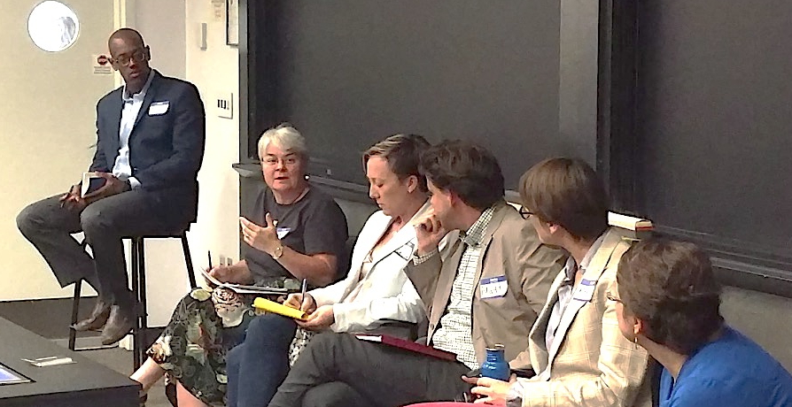
Thomas Woodson (left) moderates a panel

Boundary crossing and knowledge integration
“You are connecting social worlds, an integrator, translator.”
For many panelists, and specific to the training afforded to STS scholars is their training in facilitation and translation that allows for boundary crossing. Those skills enabled them to have careers in connecting scientists to public policy or government agencies and academic research. Others found that their STS training enabled them to convey complex messages to different audiences by first understanding the legal policy and then working to help others understand what that meant and how it might impact their organization. This supported the creation of new networks and revealed unexpected allies that were able to support their organization or specific events held by their organization.

This included uncovering how different groups ‘see’ the problem differently and thus try different solutions. As one panelist asserted that STS graduates have unique methodological skills that allow them to “explore alternative ways of thinking about problems”. Another panelist contributed with the notion that, “Problematizing and uncovering hidden assumptions and taken for granted objectives” can be a strong asset in non-academic settings and can help explain why there are conflicts between organizations or different people working on a project. For one person, the methodical process of “unpacking terms and deconstructing terms” was seen as a skill that helped their organization discover the important values and sentiments that were being expressed by members of other organizations.
One panelist shared a story about supporting knowledge integration between different factions working on a shared project to build a new technology. They felt that the insights and reflections that they shared within the group, in a positive manner, was received as a form of, “offering feedback on decisions to teams … about the social construction, shaping of technology.” This contributed to the decision-makers taking more seriously the accounts of other members of the project team.
Another panelist suggested that their STS training really helped them to “coordinate and manage science in a productive manner”, which was rewarded throughout their career. The panelist stated that their training allowed them to read and understand multi-disciplinary work and to find ways to identify projects that had strong interdisciplinary components, rather than parallel efforts by researchers from two disciplines working on disparate facets of a larger system (or problem).

Converting Academic Research Skills into Professional Skills
“Demonstrate an ability to communicate to a broader audience.”
One of the main tasks a STS Ph.D. student must do to get a non-academic job is to translate the skills they learned in graduate school to a potential employer. STS students learn research methods, how to analyze complex arguments, write, and present information. However, some Ph.D. students walk into interviews discussing their dissertation that is on a narrow field. Writing a dissertation is important, but other skills are more relevant to an employer, and therefore, should be highlighted in interviews.
STS graduates can write long, high-quality analytical pieces, but in non-academic jobs, they must write succinctly. Most non-academic jobs require people to write and read short memos, documents and decision pieces. STS grads can write these types of pieces, but in some cases, they must re-learn how to craft their argument in a few paragraphs or pages. STS graduates must also minimize their use of disciplinary language and learn to speak and write to broader audiences. Again, these skills are easy to learn, but STS graduate programs do not facilitate acquiring these abilities. To be successful in non-academic careers, STS graduate students should make an effort to write short pieces describing their work, or take classes that will allow them to write memos.
STS must also apply communication skills not formally taught in PhD programs. In industry, face to face interactions, presenting to a diverse audience, communicating through images and visuals (like a website), and interacting with the media could be important aspects of your job. These skills are especially important if the student works in a smaller organization where they have a range of roles. During graduate school, it is useful to practice media interviews or designing a personal website.

Career building skills
“There is an art of the informational interview.”
There were three concrete strategies emphasized in reference to building skills that will support a career outside of academia. The first was that the exercise of attending conferences was discussed as an avenue to build a social network and an opportunity to make contacts with organizations in the host city that might not be related to the conference. Participants were encouraged to look for events that are shortly before or after the conference that can introduce you to people in interesting organizations. Second, participants were encouraged to create publications and outputs that can be shared with future employers. Although, when one is starting out in a non-academic career, some panelists pointed out that one may write things that are published without one’s name on it, so make sure to get acknowledgements or letters of reference from the lead authors. Third, was the art and craft of informational interviews (not to be confused with job interviews). This was discussed as a way to learn about the organization, the values and culture of the place, as well as upcoming opportunities. It was strongly suggested to find a way to make a direct connection with the person that you are requesting the interview from and then work to offer something of value to them. Find ways to cultivate that as a professional relationship that can be built upon and nurtured.

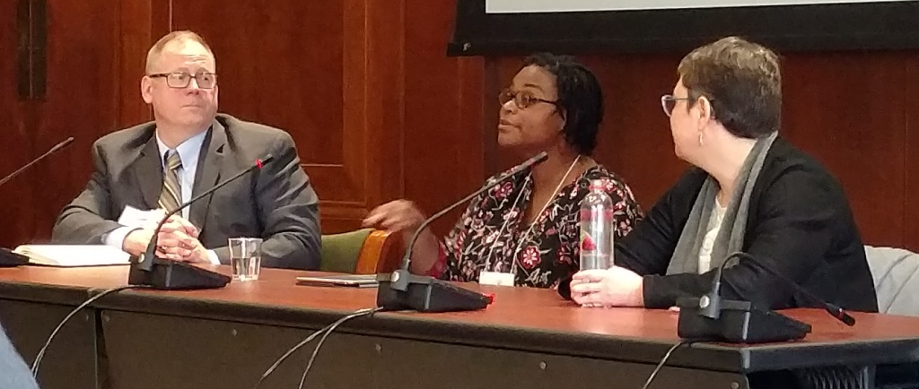

This conversation often returned to the fact that there are challenges from switching to a non-academic career. There is a new language and new set of norms outside of academia, and finding out what people value and how they communicate is important. One must understand that academia is a game with rules (implicit and explicit) and the pathway to graduation is a maze to navigate. Once one is in a new job, one needs to learn the new game, the new rules and to start exploring the maze-like pathways to success in the new job.

Skills development and lifelong learning

“Coming out of the dissertation, figure out how to love it again…”
When leaving the confines of academia and completing the dissertation, one needs to learn to love learning again. The panelists told numerous stories about how their careers involved continuous learning and skills development. People are hired based upon their past skills and experience, but that does not suggest that future success will be predicated upon that. Rather, participants were told to consider how to build out their analytical skills, people skills, project management skills, and ability to navigate multi-party agreements. STS students should continue to draw upon the skills of unpacking and describing the situation, while considering how to expand their networks or bring in new people or organizations.
The panelists encouraged participants to understand that the dissertation proved they could structure and execute a long-term project that required the coordination and management of a project team. One person said, “I market myself as a professional learner. The Ph.D. shows I can conduct research, gather and summarize information.” A key is continuing to learn and to work towards executing discrete projects that can contribute to one’s success. During those projects, one will need to acquire new analytical skills or build relationships and that is value to the individual and the employer.

Research Exists Outside Academia
“Though there are narrower boundaries on research questions, but I still get to research.”
Some of the questions from the audience reflected a heuristic that research did not exist outside the academy. One panelist confronted that sentiment directly, “I work in a research branch and I still need to submit to publications and we attend conferences.” This was qualified by another panelist, “The more you go down a non-academic path, the more applied, the less you are setting the agenda. Sometimes the best you can do is to help them understand that they are asking the wrong question, as they are likely asking the wrong questions.” The nature of research and the expectation of what counts as research demonstrated that novelty was less valued, yet fidelity and authenticity were of great importance. Decisions would be made and information crafted based upon the research conducted, as such the originality or theoretical contributions fell away and the confidence that the research had in the results took on greater importance.

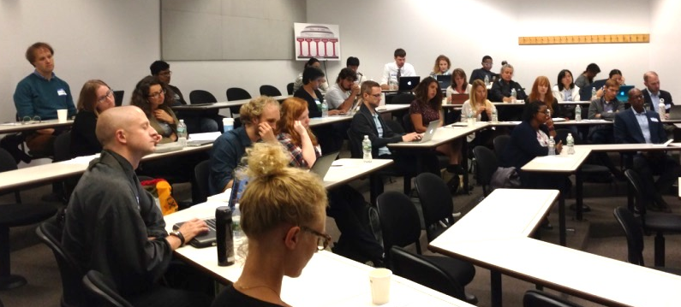

Takeaways and Concluding Thoughts
The organizers of this workshop do not oversee, administer or otherwise participate in training STS graduate students. For that reason (among others) we are not incentivized to train graduate students to enter STS academic careers, and thus, we approached this workshop as outsiders. That has allowed us the freedom to think outside the regular confines of STS departments, but it limits our ability to understand the constraints in STS graduate training, and our ability to create change from within STS graduate programs. Despite our limited reach, we believe that preparing STS graduate students to enter non-academic professions will have long-term implications for both graduate curricula and for the organizations that hire STS graduate students. Graduate programs will have to rethink how they market themselves and recruit students, and they will have to reevaluate the metrics of successful scholarship. A secondary outcome associated with enlarging the pool of jobs for STS graduates is that by showcasing a diverse range of STS careers, it is more likely that a diverse population of prospective students will enroll and graduate from STS programs. This is especially relevant because so many marginalized communities are not represented in the faculty (c.f. Mascarenhas 2018) and graduate population. Although we do not have the statistics on the lack of diversity in STS graduate student admissions, we have observed the lack of diversity at many STS conferences.
We believe that exposing students to alternative STS careers will greatly benefit STS. It gives students better perspective on future paths, relieves some of the disillusionment that occurs when students only see academia as a viable career path, and helps STS achieve greater societal impact. Pivoting STS graduate training to include preparation for non-academic jobs will not be easy, but it is important for the survival and expansion of the field.

Acknowledgements
There are a few people that worked to support these two workshops. The first was Renee Blackburn, who finished her dissertation in the weeks preceding the August 2017 workshop. Also, Ariel Ludwig and Maria Douglass, co-chairs of ST Global 2018, were very instrumental in the second panel. We also wish to acknowledge the panelists that took time to travel and serve in this capacity and for their genuine and authentic exchanges with the audience and each other. The authors would like to thank all the workshop participants and audience members at the symposia that shared their stories and engaged in a really positive dialog. Furthermore, we are grateful to the NSF-STS program that funded this effort (NSF Award #1748671). The findings and observations contained in this article are those of the authors and do not necessarily reflect the views of the National Science Foundation.

References
Cyranoski, D., Gilbert, N., Ledford, H., Nayar, A., Yahia, M. (2011) Education: The PhD Factory. Nature, 472: 276-279.
Jasanoff, S. (2016) The Floating Ampersand: STS Past and STS to Come. Engaging Science, Technology, and Society.
Mascarenhas, M. (2018) White Space and Dark Matters: Prying Open the Black Box of STS. Science, Technology and Human Values, 43(2): 151-170.

Appendix A. Workshop Agenda August 27, 2017

Appendix B. Workshop Agenda March 24, 2018
[I CAN’T FIND A COMPARABLE AGENDA]

The ampersand’s placement is not a central issue here, for those interested in that see Jasanoff’s (2016) article, “The Floating Ampersand: STS Past and STS to Come” in Engaging Science, Technology, and Society.

